CREATE TABLE BANK(

BANK_NAME VARCHAR(50) NOT NULL,

BANK_CODE INT PRIMARY KEY IDENTITY(1,1),

ADDRESS VARCHAR(100) NOT NULL

);

INSERT INTO BANK VALUES('SBI','RAJPATH');

INSERT INTO BANK VALUES('HDFC','NAYAPALLI');

INSERT INTO BANK VALUES('AXIS','SAHEED NAGAR');

CREATE TABLE BRANCH(

BRANCH_ID INT PRIMARY KEY IDENTITY(1,1),

BRANCH_NAME VARCHAR(100) UNIQUE,

ADDRESS VARCHAR(100) NOT NULL,

BANK_CODE INT FOREIGN KEY REFERENCES BANK(BANK_CODE) ON DELETE CASCADE

);

INSERT INTO BRANCH VALUES('RAJPATH','RAJPATH',1)

INSERT INTO BRANCH VALUES('NAYAPALLI','NAYAPALLI',2)

INSERT INTO BRANCH VALUES('SAHEED NAGAR','SAHEED NAGAR',3)

CREATE TABLE CUSTOMER(

CUSTOMER_ID INT PRIMARY KEY IDENTITY(1,1),

NAME VARCHAR(50) NOT NULL,

PHONE_NO BIGINT NOT NULL,

ADDRESS VARCHAR(100) NOT NULL,

)

INSERT INTO CUSTOMER VALUES('SASWAT','1234567890','KALINGA STADIUM');

INSERT INTO CUSTOMER VALUES('SAI','1234567890','BHADRAK');

INSERT INTO CUSTOMER VALUES('SWASTIK','1234567890','DHENKANAL');

INSERT INTO CUSTOMER VALUES('PIYUSH','1234567890','NIMAPADA');

INSERT INTO CUSTOMER VALUES('JANMEJAYA','1234567890','CUTTACK');

CREATE TABLE ACCOUNT(

ACCOUNT_NO INT PRIMARY KEY IDENTITY(1,1),

ACCOUNT_TYPE VARCHAR(100) NOT NULL,

BALANCE BIGINT NOT NULL,

BRANCH_ID INT FOREIGN KEY REFERENCES BRANCH(BRANCH_ID) ON UPDATE CASCADE

);

INSERT INTO ACCOUNT VALUES('SAVING','100000',1);

INSERT INTO ACCOUNT VALUES('CURRENT','1000000',1);

INSERT INTO ACCOUNT VALUES('SAVING','1200000',2);

INSERT INTO ACCOUNT VALUES('SALARY','2100000',3);

CREATE TABLE LOAN(

LOAN_ID INT PRIMARY KEY IDENTITY(1,1),

LOAN_TYPE VARCHAR(10) CHECK (LOAN_TYPE IN('PL','HL')),

AMOUNT BIGINT NOT NULL,

BRANCH_ID INT FOREIGN KEY REFERENCES BRANCH(BRANCH_ID)

);

INSERT INTO LOAN VALUES('PL',1000000,1)

INSERT INTO LOAN VALUES('PL',1020000,2)

INSERT INTO LOAN VALUES('HL',8000000,3)

SELECT * FROM BANK;

SELECT * FROM BRANCH;

SELECT * FROM CUSTOMER;

SELECT * FROM ACCOUNT;

SELECT * FROM LOAN;

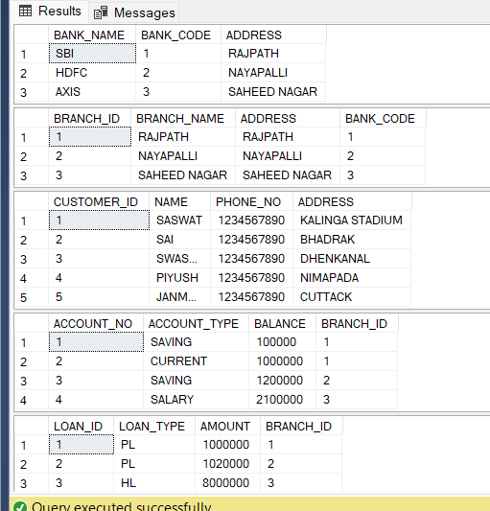OUTPUT